**Facilitators Meeting Report**

*Achieving MDGs through strengthening capacities at primary health care facilities*

**WHO Meetings with Ministry of Health, South Nation**

**Nationalities & Peoples Regional State Health Bureau for Strengthening Health Officers Training Program on**

**Integrated Management for Emergency and Essential Surgical Care (IMEESC)**

**22- 25 February 2005**

**Addis Ababa and Awassa, Ethiopia**

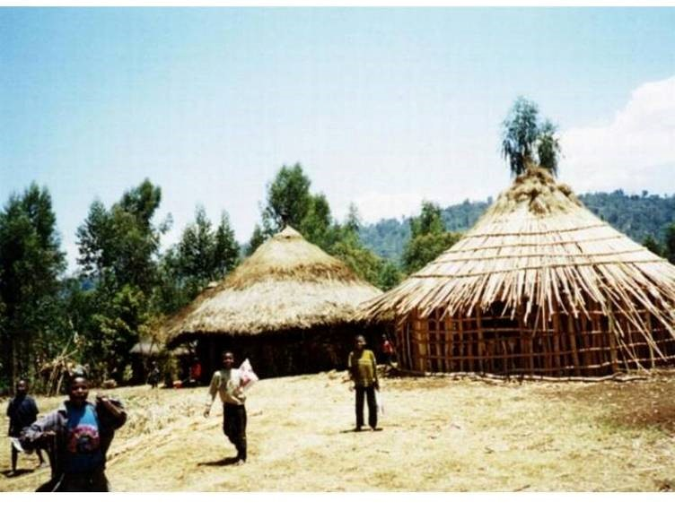

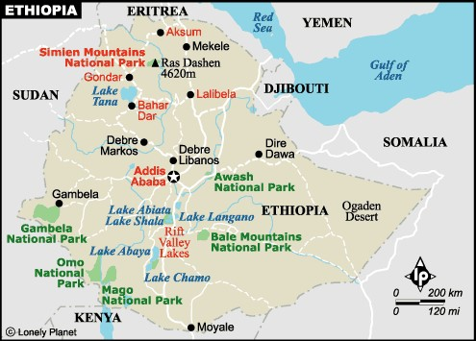

# Contents

**................................................................................................................................................Pages**

1. **Executive Summary........................................................................................................3**
2. **Background ....................................................................................................................4**
3. **Field Visits.......................................................................................................................5**
4. **WHO Meetings for facilitators .....................................................................................5** 
   1. **Objectives ...........................................................................................................5**
   2. **WHO IMEESC toolkit.......................................................................................5**
5. **Meetings at WHO country office, Addis Abba............................................................6**
6. **Meetings at Ministry of Health** **(MoH) ........................................................................7**
7. **Meetings at South Nations Nationalities and Peoples Regional (SNNPR) State**

**Health Bureau (BoH):...................................................................................................8**

1. **Recommendations and action plan...............................................................................9**
2. **Evaluation and Follow up..............................................................................................9**
3. **Conclusions .....................................................................................................................10**
4. **Acknowledgements.........................................................................................................10**
5. **Annexes............................................................................................................................11-17**

**Annexe 1: Participants list**

**Annexe 2: Programme Agenda**

**Annexe 3: WHO training tools for improving skills of health personnel**

# 1. Executive summary

The WHO project “Emergency and Essential Surgical Care” aims to strengthen training of health care personnel at primary health care facilities in emergency and essential surgical skills and linked equipment. WHO developed an *Integrated*

*Management for emergency and Essential Surgical Care* (IMEESC) tools, based on the WHO manual *Surgical Care at the District Hospital*. This tool will empower them, to manage life threatening injuries from road traffic accidents, burns, falls, drowning, domestic violence, disasters, pregnancy related complications and techniques for prevention of HIV transmission in all surgical procedures.

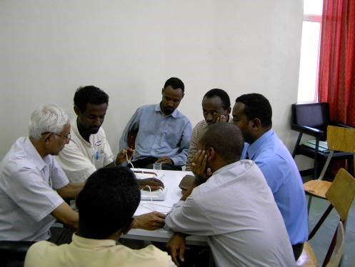 Field visits were made by a team comprising of WHO staff, country office and HQ with key health providers. Discussions were held with the staff of the health facilities (regional, district hospitals and health centres) in Addis Ababa, Awassa, and Dilla in South Nation Nationalities & Peoples Region (SNNPR). The main problems identified were lack of specialists (surgeons, obstetrics, anaesthetists), inadequate training to perform emergency surgical procedures safely for trauma, pregnancy related complications and anaesthesia, lack of basic emergency equipment linked to the emergency surgical procedures, inadequate training in use, maintenance and procurement of basic emergency equipment and lack of standard protocols.

WHO meetings were held on "Integrated Management of Emergency and Essential Surgical Care (IMEESC)" in collaboration with the MoH and SNNPR State Health

Bureau, with key focal points of the currently existing health officers training programmes, at Debub University Referral Hospital, Awassa, Yirgalem, and Dilla, supported by Tropical Health Education Trust (THET), U.K. Another multidisciplinary meeting was held with dean and directors of Health Science University, health centres, and trainers of health officers, quality assurance and public health, of Awassa region.

Regional Health Bureau will work in collaboration with the Health Science University to advise in the modification of training curriculum for health officers. WHO training materials will be incorporated in the existing THET basic emergency skills training course. Discussions with focal persons in Ministry of Health addressed the need of strengthening training of medical, nursing students, technicians and clinical officers.

MoH are in the process of training health officers in emergency obstetric care, which includes emergency surgical procedures and anaesthesia and planning to post at least 2 health officers at health centres.

Recommendations were made for preparation of a project proposal in collaboration with partners and MoH with teaching hospitals for strengthening capacities in training of health personnel in life saving emergency and basic surgical procedures and equipment in the identified 6 provinces. Prior to the health officers training, a training of trainers coordinated by WHO would be beneficial. Collaboration is envisaged with other partners such as SIDA, UNICEF, UNFPA, Japan, World Bank, GTZ, for a coordinated comprehensive approach to reduce the high maternal mortality in Ethiopia.

**2. Background:**

Ethiopia has a maternal mortality rate of 871 per 100,000 live births, and an infantmortality rate of 96.8 per 1,000 live births (2004)1. The identified causes of maternal mortality are mechanic dystocia, eclampsia, bleeding and sepsis following abortion or delivery. Mothers in drought affected areas find themselves at increased risk due to stress, poor nutritional status, poor sanitation and limited access to health services and essential drugs. The HIV/AIDS epidemic in Ethiopia started in the early 1980s and has progressed since.

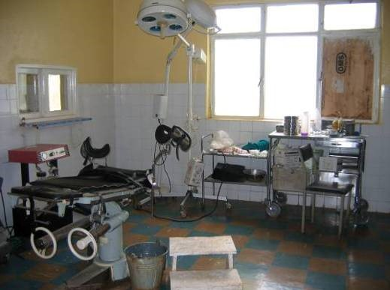 Ethiopia is a federal state, divided into nine National Regional States and the two Administrative City. The National Regional States as well as the Administrative Councils are further divided into 75 zones, 551 *woredas* (i.e. districts) and approximately 10,000 *kebeles* (i.e. counties). Each region has a Regional Health Bureau (RHB) and *Woreda* Health Office. In 2004/05, there were 126 hospitals, 519 health centres, 1,797 health stations, 2899 health posts and 1,299 private clinics in the country. The population per primary health care (PHC) facility was 24,513 and this was three times higher than the population per PHC in the rest of sub-Saharan

Africa. The total number of hospital beds was 13,469, which meant that there was only one bed for a population of 5,276 and this was about five times

higher than the average for sub-Saharan Africa. The limited number of health institutions, inefficient distribution of medical supplies and disparity between urban and rural areas has made it difficult to increase people’s access to health-care services.

The WHO project on Emergency and essential surgical Care was introduced through a WHO AFRO Regional Workshop, held in Uganda, December 2003 (report on the website) to key decision makers representing 10 countries in Africa and international partners. This created an interest among health providers to organize WHO meetings/workshops to sensitize stakeholders to address Emergency and essential surgical Care as a public health issue.

**3. Field visits to health facilities:**

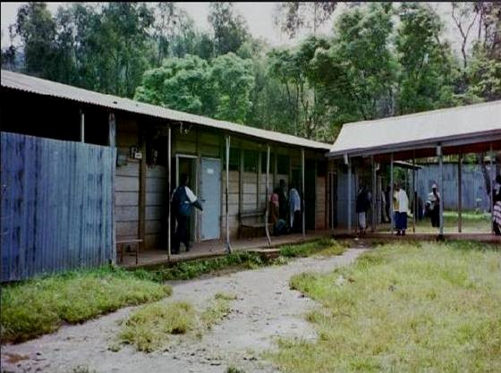A team comprising of WHO staff, country office and HQ with key health providers visited the health facilities (regional, district hospitals and health centres) in Addis Ababa, Awassa, Yirgalem, and Dilla in South Nation Nationalities & Peoples Region (SNNPR). Visits were made in particular to the emergency/admissions rooms, operating rooms, postoperative wards and discussions held with the hospital director, doctors, nurses, and health officers.

Following health facilities were visited:

* Awassa Referral hospital
* Southern University College of Health Sciences, Awassa
* Yirgalem hospital (district level hospital),
* Dilla hospital
* Yirgachefe health centre
* Altawondo Health centre
* Zewditu Memorial Hospital, Addis Ababa
* Tikur Anbassa Specialized Hospital (University Hospital), in Addis Ababa

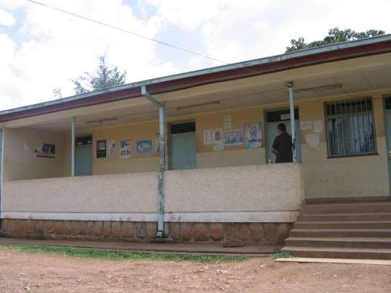 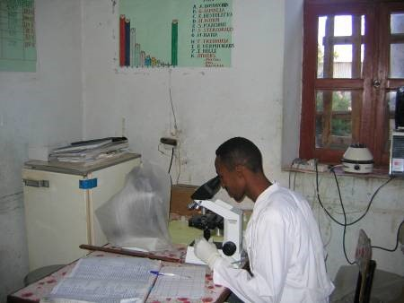

1. 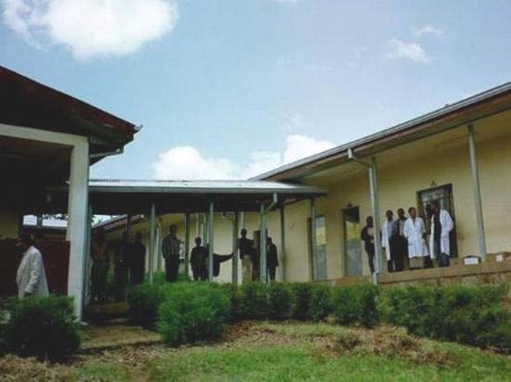**WHO Meetings for facilitators :**

WHO meetings were held on "Integrated Management for Emergency and Essential Surgical Care (IMEESC)" in collaboration with the MoH and SNNPR State Health Bureau, Ethiopia. These meetings brought health providers, policy makers and partners together, with an overall aim to facilitate a collaborative and integrated approach to improve emergency and essential surgical care at primary health care facilities.

**4.1 Objectives of the meetings:**

The overall objective was capacity building to improve the quality of emergency and essential surgical care at resource-limited healthcare facilities, to meet the MDGs in Ethiopia.

*Specific objectives:*

* Introduction of the WHO IMEESC toolkit
* Collaboration to strengthen capacities through a standardized training tool including common cross cutting issues towards health personnel and patient safety at resource limited health care facilities

**4.2 Introduction to the WHO Integrated Management for Emergency and Essential Surgical Care** (**IMEESC) toolkit**

Dr Meena Cherian, WHO/Essential Health Technologies, HQ, introduced the Clinical Procedures unit, responsible for provision of guidance and support to implementation of safe, efficient and appropriate essential surgical care at first-referral level health facilities and for assuring the ethics, safety and quality of cell, tissue and organ transplantation.

The participants were introduced to the use of WHO IMMESC e-learning toolkit based on the WHO training manual *‘Surgical Care at the District Hospital’* (SCDH) for reference and for incorporation of standard WHO recommendations on the cross-cutting issues into their training programs for improving quality of emergency and essential surgical procedures with linked equipment at resource-limited health care facilities.

This toolkit is aimed at policy makers and health providers to provide guidelines on minimum requirements to improve emergency and essential surgical care at resource limited health care facilities. It contains four CDs on training videos *Surgery at the District hospital* andone CD with the following contents:

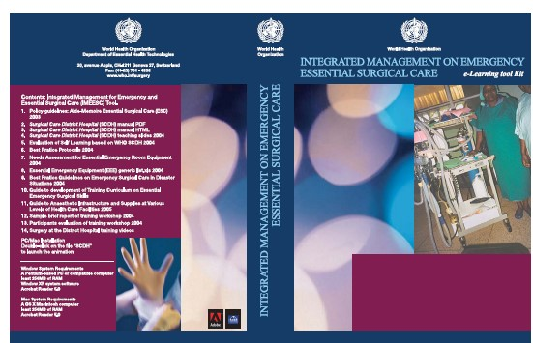

*Policy materials:*

--- Policy guidelines: Aide-Memoire Essential Surgical Care

* Needs Assessment for Essential Emergency Room Equipment
* Essential Emergency Equipment generic list.xls Guide to Development of a Training

Curriculum on Essential Emergency Surgical Skills

* Guide to Anaesthetic Infrastructure and Supplies at Various Levels of Health Care Facilities

*Teaching and training materials:*

--- Surgical Care District Hospital (SCDH) manual pdf and html

--- Surgical Care District Hospital (SCDH) teaching power point

* Evaluation of Self Learning based on WHO manual SCDH
* Best Practice Protocols for Clinical Procedures Safety
* Best Practice Guidelines on Emergency Surgical Care in Disaster Situations
* Sample brief report of training workshop
* Participants evaluation of training workshop
* Model Agenda training workshop

1. **Meetings at WHO country office, Addis Abba:**

Meetings were held with Dr Babaniyi,WHO/WR/Ethiopia, Dr Abonesh (Program

Officer national Health,WHO), Dr Ato Haddis (WHO), Dr Kidane (National Program Officer,WHO and MoH), Dr Tsega Kebede and Dr Tezera Chaka (Trauma Care, University Hospital).

Discussions addressed the following issues:

* + A horizontal approach for the integration of emergency and essential surgical care at first referral level health care facilities is needed. These include cross cutting issues for life saving procedures in injuries as a result of road traffic accidents and violence, caesarean section, unsafe abortion, obstetrics fistula, HIV, infection control, control of bleeding, resuscitation and anaesthesia. This could involve incorporation and implementation of the WHO Integrated Management Package on Emergency and Essential Surgical Care (IMEESC) for strengthening pre-service training and education programs in at health centres.
  + WHO Training of Trainers workshop in collaboration with MoH, for policy makers, health providers and partners involved in training and education of health officers, doctors, nurses, technicians.
  + Existing WHO collaborations with Associations of Surgeons of East Africa (ASEA) and international (Canada, U.K, Germany, USA, Belgium) surgical and anaesthesia associations, and universities involved in training in emergency and surgical care at universities and health centres, in Ethiopia. Partners such as Tropical Health Education Trust (THET) is involved in currently existing health officers training, Canadian Network International Surgical Society (CNIS) conducts instructors workshops for the ESS program every 3 years in each department. German Association of Surgeons conduct surgical skills for medical students from Jimma University
  + Coordination between vertical programs on crosscutting issues for better utilization of limited resources
  + Work towards a standardized training and accreditation of health facilities.

1. **Meetings at Ministry of Health** **(MoH)**

Meetings were held with Dr Tedros, State Health Minister, Dr Girma Azene, Head of Department of Planning & Programming, Dr Eyob Kamil, Bureau Head, Addis Ababa City Government Health Bureau, Dr Tesfenesh Belay, Head Family Health, Dr Ato Yohannes Tadesse, Head of Training and Health Services.

Discussions to address the reduction of high maternal mortality, led to the following consensus:

* + Health centres have the following problems:
    - lack of specialists (surgeons, obstetrics, anaesthetists)
    - Inadequate training to perform emergency surgical procedures safely for trauma, pregnancy related complications and anaesthesia.
    - lack of basic emergency equipment linked to the emergency surgical procedures
    - inadequate training in use, maintenance and procurement of basic emergency equipment
    - lack of standard protocols
    - lack of coordination with the vertical programmes in cross cutting issues
  + MoH are in the process of planning to post at least 2 health officers at health centres. To expedite the process more number of health officers (5000) will be trained within a few years, starting October 2005, rather than waiting to increase the number until 2015. A WHO coordinated training of trainers would be beneficial prior to the start of the health officers training course.
  + Train health officers in emergency obstetric care, which includes emergency surgical procedures and anaesthesia. These interventions will result in health officers becoming more confident to perform basic emergency surgical and anaesthetic procedures, with a decrease in referrals and over load, of emergencies with delayed complications in these referral hospitals.
  + Collaborate with other partners such as SIDA, UNICEF; UNFPA, Japan, World Bank, GTZ, for a coordinated comprehensive approach to reduce the high maternal mortality in Ethiopia.

1. **Meetings at South Nations Nationalities and Peoples Regional (SNNPR) State Health Bureau (BoH)**:

The SNNPR-BOH is one of the nine regions and two urban administrations in Ethiopia. Located in the South and Southwestern part of the country, and following the system of decentralized governance the region is organized in 13 Zones and 104 Districts.

With the policy emphasis towards primary and preventive health care services; the health sector is organized in four-tier system: primary health care units that comprise health posts and health centers, district hospital, zonal hospital, and regional referral hospital. Currently, there are 15 hospitals, 127 Health centers and 450 health posts within the mandate of SNNPR-BOH.

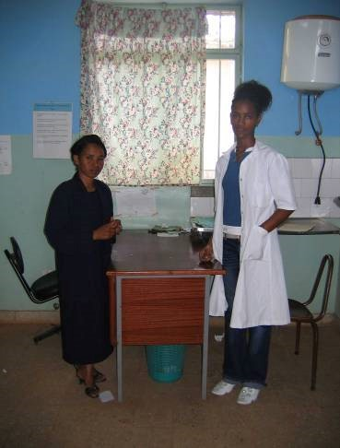SNNPR is one of the regions with highest maternal and neonatal morbidity and mortality. The major reason behind is lack of access to essential obstetric care and inadequate care during pregnancy and childbirth. Only a few hospitals are providing emergency obstetric care and all most all of health centers do not have a capacity to manage obstetric cases when the complication arise during pregnancy, delivery, or post partum period.

The existing regional training institutions are not in the position of satisfying the sector’ skilled manpower requirement due to multifaceted deficiencies such as critical shortages of instructors (in terms of quality as well as quantity), lack of reference books, insufficiency of

infrastructures, poor logistic facilities, scarcity of budget, and poor capacity of practical training at health care delivery facilities. Currently SNNPR-BOH is striving to enhance the capacities of existing midlevel health professionals so as to produce the required manpower in terms of quantity and skill mixes.

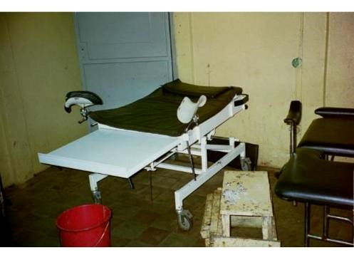Dr Shiferaw, Head, Regional Health Bureau organized the following meetings for the presentation of WHO training tools:

**7.1** **Meeting with key focal points** in the currently existing health officers training at Awassa, Yirgalem and Dilla by Dr Sunirmal Ghosh,

Consultant Surgeon,UK, Tropical Health Education Trust (THET), U.K, Dr Aberra Medical Director, Debub University Referral Hospital, Awassa.

The following issues and plans were discussed :

* Expansion of the Existing Health Science Colleges such as three midlevel diplomagraduating colleges namely Awassa Health Science College, Arbaminch Health Science College, and Hosanna Health Science College have been reorganized
* Upgrading of Health Assistants into Clinical Nurses to improve the capacity levels of different professionals through in-service training in different colleges, universities, and hospitals. Specifically health bureau intended to upgrade all health assistants to midlevel clinical nurses in the short run.
* Emergency Obstetrics Skill Upgrading to build the capacity of the health worker in skill of Emergency obstetric care and support the health facilities with necessary vital or life saving emergency equipment in hospitals where there is no specialized professionals. The training team also includes clinical nurses so that they can acquire skills to provide anesthesia and assist in operative procedures. A total of 13 high volume health facilities are targeted to be included in this plan.
* Distance Education
* Logistics Improvement and Management Information System

**7.2 Meeting with in a multidisciplinary group** responsible for implementation of policies, training and education of health officers in the emergency and essential surgical care. Participants included, dean and directors of Health Science University, health centres, trainers of health officers, quality assurance and public health, of Awassa region Discussions were held to address:

* + - The role of partners in the integration of WHO tools for training of health officers in SNNPR.
    - Increasing the number of health officers trained and modifying the present training curriculum, to not only to meet quantity but also quality.
    - Regional Health Bureau will work in collaboration with the Health Science University to advise in the modification of training curriculum for health officers.
    - Strengthening the practical skills of health officers through incorporation of WHO training materials in the existing THET basic emergency skills training course.
    - The non specialist doctors, nurse anaesthetists and health officers at the rural and primary healthcare facilities discussed that the training was often inadequate to give them the confidence to performing emergency surgical procedures, including anaesthesia and use of equipment in the life threatening conditions in trauma, infection, and pregnancy related complications.

# 8. Recommendations and Action plan

The deliberations in all the meetings held resulted in the following recommendations:

* The meetings report should be shared with all the participants and can be used for dissemination to local and international partners interested in improving access to emergency and basic surgical care at resource limited health care facilities .
* Consider possibilities of local printing of the WHO manual Surgical Care at the District Hospital, for training and education.
* Collaborations for joint proposals to improve emergency surgical care at resource limited health care facilities to reduce death and disability with emphasis on women and children.
* The WHO IMEESC toolkit will be used to plan the training curriculum of Clinical Officers in Ethiopia to strengthen medical and nursing education, continuos medical education programs with a standardized training.
* Training at district hospitals and community level should be strengthened to manage injuries (road traffic accidents, burns, drowning, falls) and pregnancy related complications
* The MoH should nominate a focal department to work with WHO on piloting of IMEESC in Ethiopia.
* Preparation of a project proposal identifying districts for introduction of the WHO IMEESC tool in collaboration with partners and MoH with teaching hospitals for strengthening capacities in training of health personnel in life saving emergency and basic surgical procedures and equipment.
* Finalize proposal for training of trainers workshop (to train health officers, doctors and nurses) in emergency and essential surgical care with tentative dates for 2005.

# 9. Evaluation and follow up

This training of facilitators and stakeholders meetings will be followed by further training workshops as suggested by the MoH, WHO and partners in 2005.

# 10. Conclusions

The meetings gave the participants the understanding to use a standard WHO training tool to improve the quality of basic emergency and surgical intervention skills at primary healthcare facilities with a horizontal approach. It also resulted in a plan to prepare a clinical officers training curriculum by MoH with WHO, country office.

# 11. Acknowledgements to collaborations and support

* Ministry of Health Ethiopia
* SNNR State Healh Bureau, Awassa
* Directors of Teaching, Regional Hospitals, Health Centres, Addis Ababa and Awassa
* Surgical Association of Ethiopia
* Southern Ethiopia-Gwent Health Link
* Tropical Health Education Trust (THET), U.K,
* British Embassy, Ethiopia
* Canadian Network International Surgical Society, Canada
* Association of Surgeons of South East Africa
* German Association of Surgeons, Germany
* Departments of Essential Health Technologies, Evidence and Information for Policy, Making Pregnancy Safer, Violence and Injury Prevention, Child Health and Adolescent, WHO/ HQ/Country office/Regional Office.

**12.** **Annexes**

1. Annexe 1: Participants list
2. Annexe 2: Program Agenda
3. Annexe 3: Needs Assessment and Evaluation Form For Resource Limited Health Care Facility and WHO Generic Essential Emergency Equipment List

**Annexe 1 List of participants for meetings**

Dr Tedros A Ghebreysus,

State Minister,

Fedral Ministry of Health

Adis Ababa, Ethiopia

Dr Shiferaw Tekelmariam

Head, South Nations and Nationalites and

Peoples Region,State Health Bureau ,

(SNNPR-BOH)

Awassa, Ethiopia

mobile no -09237530

Dr. Girma Azene

Consultant Health Sciences Specialist

Head, Department of Planning and

Programming

Ministry of Health Addis Aababa, Ethiopia

moh@telecom.net.et

Dr. Eyob Kamil

Bureau Head

Addis Ababa City Government Health

Bureau

Adis Ababa, Ethiopia

Dr. Ato Yohannes Tadesse

Head of Training and Health Service

Department

Ministry of Health

Addis Aababa, Ethiopia

Dr, Tesfenesh Belay

Head, Family Health Department Ministry of Health

Addis Aababa, Ethiopia

Dr Tsegazeab Kebede

Consultant Surgeon Consultant on Pre-hospital care and emergency care, Injury prevention and road safety tel: 0911208345(mobile) P.O.Box 15836 e-mail:tsegaz@yahoo.com,

Addis Ababa, Ethiopia

Dr Tezera Chaka

Consultant Orthopedic Surgeon

Head , Department of Orthopedics

Adia Ababa University, Faculty of

Medicine

Tel:0911621120 P.O.Box e-mail:tchaka50@yahoo.com

Addis Ababa, Ethiopia

Dr Aberra A Gobezie

Southern Ethiopia-Gwent Health Link

Coordinater

Medical director, Debub University

Referral Hospital, Awassa, Ethiopia mobile no - 0916824834

aberraG2000@yahoo.com

Dr Sunirmal Ghosh,

Consultant Surgeon and Secretary

Southern Ethiopia-Gwent Health Link

Nevill Hall Hospital

Brecon road, Abergavenny, Wales

U.K

Tel 00441873732439

BikuGhosh@aol.com

Dr Zelalem Kebede

Head, Southern University College of

Health Sciences, Awassa, Ethiopia mobile no -091827598

Dr Asfowssen Bekele

Dean, faculty of medical sciences

Awassa, Ethiopia

Dr Nebiyu

Surgeon, Dilla hospital

Dilla

Awassa, Ethiopia

Dr Ato Basmo,

Head of training,

Yirgalem Hopsital

Yirgalem

Awassa, Ethiopia

National Program Officer,WHO

Dr Samson Addis Ababa, Ethiopia

Obstetrician

Awassa College of Health Dr Meena Nathan Cherian

Sciences(ACHS) Project: Emergency & Essential Surgical Care

Ethiopía Clinical Procedures Unit (CPR)

Department of Essential Health Technologies

Sister Workie World Health Organization, Geneva, Switzerland

Anaesthetic Nurse tel:0041 22 791 4011; fax: 0041 22 791 4836

Dilla Hospital cherianm@who.int; www.who.int/surgery

Ethiopía

Sister Meskerem

Paediatric Nurse,

Dilla Hospital

Ethiopía

Prof. E Parry,

Chairman, Tropical Doctor

Tropical Health Education Trust (THET)

UK

Tel 0044 2076798210

Dr. Adriana Ignea dres_ignea@yahoo.de Tel: 0025 11 551 88 56

Addis Ababa, Ethiopía

Dr.Johann Ignea

Tel: 0025 47 111 7989 / 0025 97

Jimma, Ethiopía

**WHO secretariat:**

Dr Olusegum Ayorinde Babaniyi,

WHO Representative

WHO/WR/Ethiopia, Addis Ababa, Ethiopia

adugnat@et.afro.who.int]

Dr Abonesh HaileMariam

Program Officer, Family Health,

WHO, Country Office

Addis Ababa, Ethiopia

Dr Ato Haddis (WHO),

WHO, Country Office

Addis Ababa, Ethiopia

Dr Kidane Ghebrekidan

Obstetrician with MOH

**Annex 2: Program Agenda**

# WHO Integrated Management for Emergency & Essential Surgical Care

22-25 February 2005, Addis Ababa, Ethiopia

1. **Meetings with focal persons in WHO country office, Ethiopia**

1. **Visits and meetings with directors of:** 
   * Teaching hospital
   * District Hospital
   * Commune hospital
   * Primary health care facilities

1. **Meetings with Ministry of Health departments, Addis Ababa, Ethiopia**

- Need for Strengthening training at primary health care facilities: State Minister of Health

1. **Meetings at SNNPR Regional Health Bureau, Awassa, Ethiopia**

* + **Opening remarks** 
    - Health profile: Head Regional Health Bureau
    - Role of WHO project emergency and essential surgical care to reduce death and disability in injuries: WHO /country office
    - The WHO Clinical Procedures unit: Improving emergency and essential surgical care at resource limited health care facilities : WHO /HQ

* + **Presentations on Situation analysis and needs of emergency care at first referral level health facilities in SNNPR**

* + **Introduction to the WHO “Integrated Management on Emergency and Essential Surgical Care (IMEESC) tool kit ”**

* + **Round table discussions**

* + - Strengthening capacitieswith an integrated approach for Health Officers training in Ethiopia
    - WHO IMEESC tool as a standard training for clinical officers, medical and nursing students
    - Collaborative approach & integration to emergency procedures in trauma, obstetrics, anaesthesia, infections (HIV), patient safety at first referral level health facilities linking training materials from other WHO departments.
    - Evaluation forms for assessment of quality of care at first referral level health facilities.

* + **Recommendations and action plan**
  + **Closing remarks**

**Annexe 3**

# Needs Assessment and Evaluation Form for Resource Limited Health Care Facility

**Essential Emergency Equipment in Emergency Room\***

**\***At an entry point in any health facility such as:

Emergency room/ Admission room / Treatment room/ Casualty room

1. **Name/Address of Health Care Facility**

______________________________________

______________________________________

**Country** ______________________________________

1. **Type of Health Care Facility** (please check one)

* Primary or First referral level facility/ District Hospital/Rural Hospital 
* Health Centre 

3. **Human Resources** in emergency room (please indicate number of health staff)

 Doctors ___ Nurses ___ Clinical or Health officers ____  Technicians ___ Paramedical staff ___

4. **Physical Resource**

1. Infrastructure

|  |  |  |  |
| --- | --- | --- | --- |
|  Is there an area or room designated for emergency care? | **Yes** |  | **No** |
|  |  |  |
| * Is there running water? * If yes: Interrupted / Uninterrupted (please circle one) |  |  |  |
| * Is there an electricity source? * If yes: Interrupted / Uninterrupted (please circle one) |  |  |  |

1. Equipment **Yes No**

* Is a list of essential emergency care equipment available?  
* Is following available
* Oxygen Cylinder: Interrupted /Uninterrupted (please circle one)  
* Oxygen Concentrator: Interrupted /Uninterrupted (please circle one)   - Equipment for oxygen administration available (tubes, masks)  

|  |  |  |  |  |
| --- | --- | --- | --- | --- |
| Essential Emergency (EE) Equipment | **Yes, in some equipment** | **Yes, in all**  **equipment** | | **No** |
|  Are the EE equipment in working order?  | |  | |  |
|  Is there access to repair if equipment fails?  | |  | |  |
|  Is there access to repair within the health care facility?  | |  | |  |
|  Is there access to repair outside the health care facility?  | |  | |  |
|  If yes, how far (in km): 1-25 / 26-50 / 51-200 / >200 (please circle one) | | | |  |
|  Is there an agreement for the maintenance of the   equipment with the supplier? | | | |  |
|  Do the health care staff in the emergency room get   training in the use of the equipment? | | | |  |
|  Is information available on supply, repair, and spare parts for the equipment? |  |  |  | |

1. **Quality, safety, access and use**

|  |  |  |  |
| --- | --- | --- | --- |
|  Are the best practice protocols for management of essential emergency procedures available? | **Yes, in some procedures** | **Yes, in all procedures** | **No** |
|  |  |  |
|  Are the protocols for safe appropriate use of equipment in essential emergency procedures available? |  |  |  |

|  |
| --- |
|  How often is ‘room to room inspection’ performed to ensure that **EE equipment** and supplies required for the essential emergency procedures are available and  functioning? (please circle one)  Daily / weekly / monthly / 6-monthly / yearly / once in ___ years / never |

|  |  |  |
| --- | --- | --- |
|  Are the information, education and training materials on emergency procedures and equipment available in the emergency room for health care staff use? | **Yes** | **No** |
|  |  |
| * Are there introductions of any new procedures/interventions? * If yes, which procedure/intervention: (please specify)     __________________________________ |  |  |
|  Has referral to other health facility decreased because of skills and knowledge of procedures and intervention? |  |  |
|  Are records maintained ? |  |  |

1. **Policy**

|  |  |  |
| --- | --- | --- |
|  Is there a policy to promote training for health care staff in the essential emergency management of trauma, obstetric care and anaesthesia? | **Yes** | **No** |
|  |  |
|  Is there a policy to update the protocols for the emergency management of trauma and obstetric care adapted to local needs? |  |  |
|  Are there any guidelines on donation, procurement, and maintenance of all EE equipment? |  |  |
|  Is there a list of extra health personnel to be contacted in disaster situations? |  |  |

## For guidance use WHO generic list of Essential Emergency Equipment

[Department of Essential Health Technologies](http://www.who.int/eht)

World Health Organization,

20 Avenue Appia, 1211, Geneva 27,Switzerland

Fax: 41 22 791 4836 Internet: [www.who.int/surgery](http://www.who.int/surgery)

### WHO Generic Essential Emergency Equipment List

***This checklist of essential emergency equipment for resuscitation describes minimum requirements for essential emergency surgical care at the first referral health facility(small or rural hospital/ health centre)***

**Capital Outlays Quantity Date checked**

Resuscitator bag valve and mask (adult)

Resuscitator bag valve and mask (paediatric)

Oxygen source (cylinder or concentrator)

Mask and Tubings to connect to oxygen supply

Light source to ensure visibility (lamp and flash light)

Stethoscope

Suction pump (manual or electric)

Blood pressure measuring equipment

Thermometer

Scalpel # 3 handle with #10,11,15 blade;

Scalpel # 4 handle with # 22 blade

Scissors straight 12 cm

Scissors blunt 14 cm

Oropharyngeal airway (adult size)

Oropharyngeal airway (paediatric size)

Forcep Kocher no teeth 12-14 cm

Forcep, artery

Kidney dish stainless steel appx. 26x14 cm

Tourniquet

Needle holder

Towel cloth

Waste disposal container with plastic bag

Sterilizer

Nail brush, scrubbing surgeon's

Vaginal speculum

Bucket, plastic

Drum for compresses with lateral clips

Examination table

Wash basin

**Renewable Items**

Suction catheter sizes 16 FG

Tongue depressor wooden disposable

Nasogastric tubes 10 to 16 FG

Batteries for flash light (size C)

Intravenous fluid infusion set

Intravenous cannula # 18, 22, 24

Scalp vein infusion set # 21, 25

Syringes 2ml

Syringes 10 ml

Disposable needles # 25, 21, 19

Sharps disposal container

Capped bottle, alcohol based solutions

Sterile gauze dressing

Bandages sterile

Adhesive Tape

Needles, cutting and round bodied

Suture synthetic absorbable

Splints for arm, leg

Urinary catheter Foleys disposable #12, 14, 18 with bag

Absorbent cotton wool

Sheeting, plastic PVC clear 90 x 180 cm

Gloves (sterile) sizes 6 to 8

Gloves (examination) sizes small, medium, large

Face masks

Eye protection

Apron, utility plastic reusable

Soap

Inventory list of equipment and supplies

Best practice guidelines for emergency care

### Supplementary equipment for use by skilled health professionals

Laryngoscope handle

Laryngoscope Macintosh blades (adult)

Laryngoscope Macintosh blades (paediatric)

IV infusor bag

Magills Forceps (adult)

Magills Forceps (paediatric)

Stylet for Intubation

Spare bulbs and batteries for laryngoscope

Endotrachael tubes cuffed (# 5.5 to 9)

Endotrachael tubes uncuffed (# 3.0 to 5.0)

Chest tubes insertion equipment

Cricothyroidotomy

**This list was compiled from the following WHO resources:**

WHO training manual: *Surgical Care at the District Hospital*

WHO Emergency Relief Items, Compendium of Basic Specifications

WHO/UNFPA Essential drugs and other commodities for reproductive health services.

WHO Essential Trauma Care Guidelines

*\* For specifications refer to this book*

[Department of Essential Health Technologies](http://www.who.int/eht)

World Health Organization

20 Avenue Appia, 1211, Geneva 27, Switzerland

FAX 41 22 791 4836 [www.who.int/surgery](http://www.who.int/surgery)